cnc_vrfend4

声明
/* end of verification */
[DllImport("FWLIB32.dll", EntryPoint = "cnc_vrfend4")]
public static extern short cnc_vrfend4(ushort FlibHndl);

描述
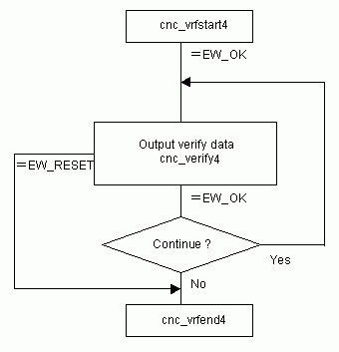

参数
（1）FlibHndl 库句柄；[ in ]
（2）dir_kind [ in ]
设置读取的当前文件夹类型：
1 : Foreground
2 : Background
（3）dir_name [ out ]

函数返回值
函数运行正常返回EW_OK。
Return code | Meaning/Error handling
EW_FUNC  (1) | cnc_vrfstart4 function has not been executed.
EW_DATA  (5) | Data error  In order to get more information for this err_no return value, execute cnc_getdtailerr function.  The following detail status will be set onto the member, err_no of ODBERR structure.  See Description about the timing of error.
  1 | : | A character which is unavailable for NC program is detected.
  2 | : | When TV check is effective, a block which includes odd number of characters(including 'LF' at the end of the block) is detected.
  3 | : | Any difference has been detected during comparing process.
EW_REJECT  (13) | CNC execution denied  Downloading is disable in the current CNC status.  (Machining, resetting, mode changing)  See Description about the timing of error.
EW_ALARM  (15) | Alarm state  Alarm has occurred while downloading.  See Description about the timing of error.

代码
class Program
{
static void Main(string[] args)
{
ushort Flibhndl = 0;

short ret; // 返回值

// 获取库句柄 ( Ethernet )
ret = Focas1.cnc_allclibhndl3("192.168.0.224", 8193, 10, out Flibhndl);
if (ret != Focas1.EW_OK)
{
Console.WriteLine("发生异常，请检查！");
return;
}

#region cnc_vrfstart4

string prg = "\nO1234\nM3 S1200\nG0 Z0\nG0 X0 Y0\nG1 F500 X120. Y-30.\nM30\n%";
int len = 0;
int n = 0;

ret = Focas1.cnc_vrfstart4(Flibhndl, "//CNC_MEM/USER/PATH1/");
if (ret != Focas1.EW_OK) return;

len = prg.Length;
while (len > 0)
{
n = len;
ret = Focas1.cnc_verify4(Flibhndl, ref n, prg);
if (ret == (short)Focas1.focas_ret.EW_BUFFER)
{
continue;
}
if (ret == Focas1.EW_OK)
{
prg += n;
len -= n;
}
if (ret != Focas1.EW_OK)
{
break;
}
}
ret = Focas1.cnc_vrfend4(Flibhndl);

#endregion
}
}

